NGINX

What is Nginx?

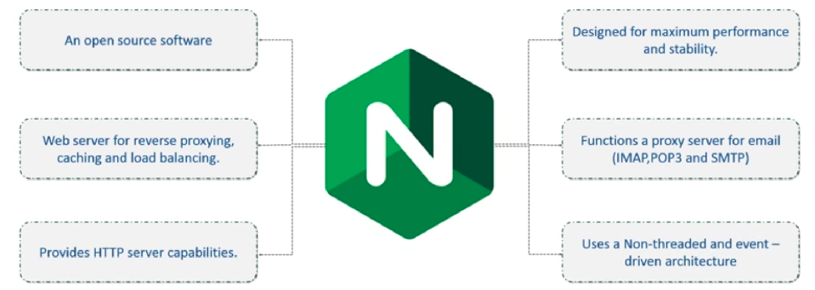
Nginx Architecture

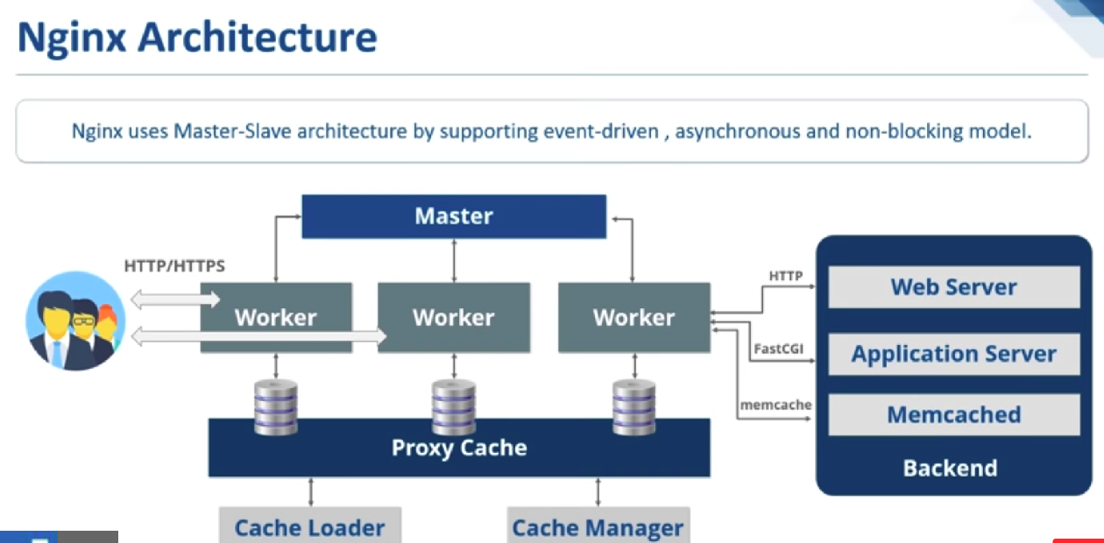

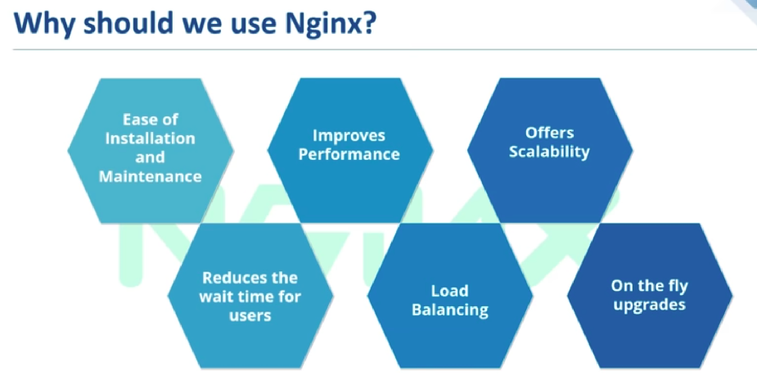

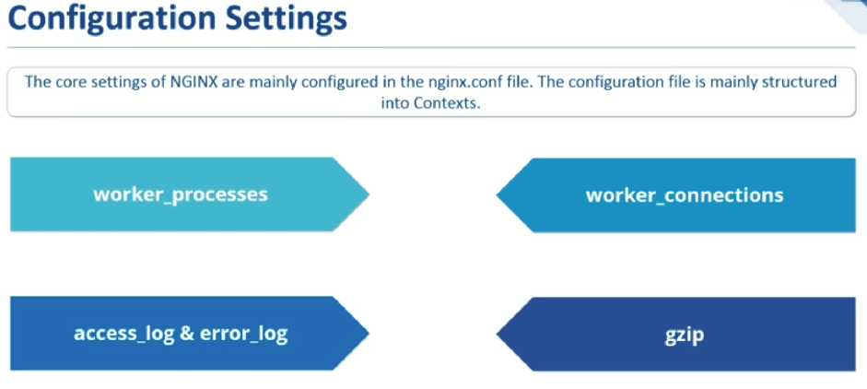

NGINX COMMANDS

( These commands are in sequential manner )

- Sudo apt-get install nginx
- Sudo ufw enable
- Sudo ufw app list

Port 80 ==> for unencrypted web trafic
Port 443 ==> for encrypted web trafic
Nginx HTTP ===> It poens port 80
  - Nginx HTTPS ===> It opens port 443
  - Ngins Full ===> It allows both port 80 and 443

- sudo ufw allow ‘Nginx Full’
- sudo ufw allow ‘Nginx HTTP’
- sudo ufw allow ‘Nginx HTTPS’

- sudo ufw status

To check whether nginx server is working or not
- sudo systemctl status nginx

- sudo systemctl start nginx
- sudo systemctl stop nginx
- sudo systemctl restart nginx
- sudo apt-get purge nginx nginx-common (to remove nginx completely)

LOAD BALANCING

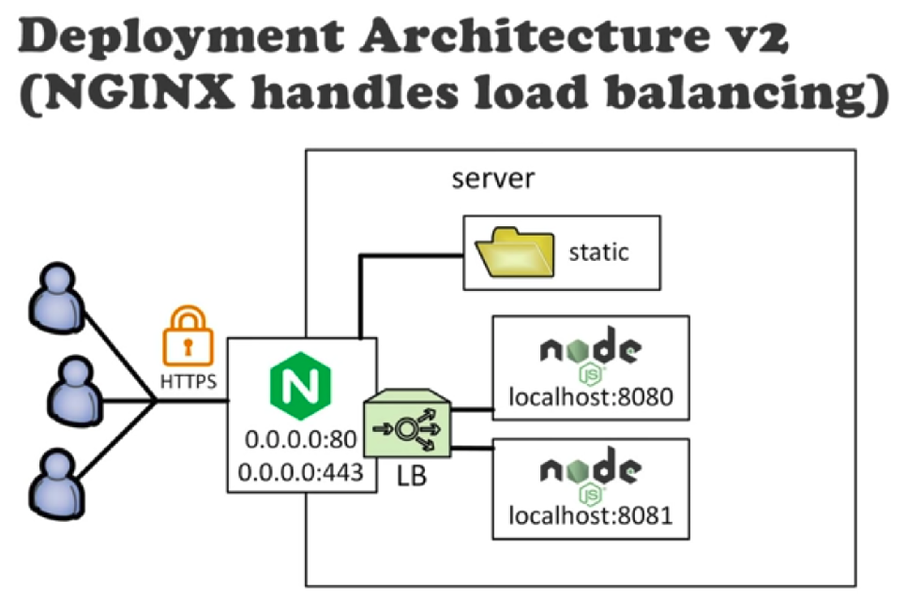
Why Load Balancing?

- Distributing the load between processes
- Failover: while one node is down, users are served by other nodes
- Zero Downtime Redeploy

